**Nginx Ubuntu and Amazon Linux**

**Managing the Nginx Process:**

sudo service nginx restart   
sudo systemctl restart nginx  
sudo systemctl stop nginx  
sudo systemctl start nginx  
sudo systemctl disable nginx  
sudo nginx -t (for test conf file)

**Install Ubuntu:**$ sudo apt-get install nginx  
  
**Install Amazon-linux:**$ sudo amazon-linux-extras install nginx1

**Remove to reinstall:**$ sudo apt-get purge nginx  
or  
$ sudo apt-get purge nginx nginx-common nginx-full

**Start service:**$ sudo service nginx start

**Onde ficam os arquivos por padrão:**/usr/share/nginx/www  
2022: /usr/share/nginx/html

**Para permitir listar o diretório de uploads do WordPress adicionar uma nova linha:**

location /wp-content/uploads {

autoindex on;

}

**ON Amazon Linux:**

root /usr/share/nginx/html;

autoindex on;

**Servers blocks (Virtual hosts, requer domain-name):**

**Criar o diretório:**  
$ sudo mkdir –p /var/www/drivebr

**Permissões:**  
$ sudo chown -R www-data:www-data /var/www/drivebr

**Amazon-Linux foi usado, mesmo em tutorial sobre Ubuntu 20.4 ambos devem funcionar**sudo chown -R $USER:$USER /var/www/your_domain/html

**Create a index.html ou just**$sudo echo "<h1>title</h1>" > index.html

<html>  
 <head>  
 <title>Welcome to your_domain!</title>  
 </head>  
 <body>  
 <h1>Success! The your_domain server block is working!</h1>  
 </body>  
</html>

**Ubuntu fazer uma cópia do arquivo de configuração:**

$ sudo cp /etc/nginx/sites-available/default /etc/nginx/sites-available/drivebr.com

$ sudo vim /etc/nginx/sites-available/drivebr.com

**Faça as alterações:**

Primeiro block é para o IP de modo geral, se quiser pode deixar padrão add directory algum site ou aviso,   
Se comentar as **linhas default** o IP vai mostrar a página inicial de um dos virtuais hosts

A partir de Virtual Host configuration é só descomentar as linhas:

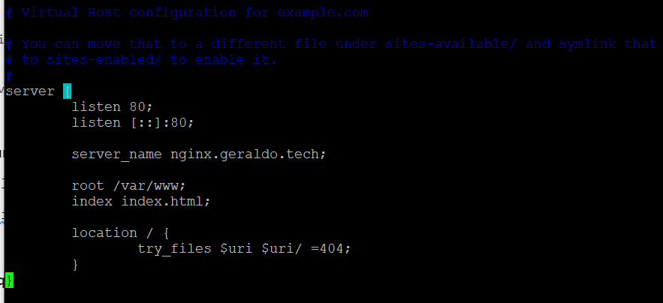

**Add another virtual Host (Ubuntu 2022)**

Repetir os passos anteriores symbolic links usar o code abaixo:

server {

listen 80; ## listen for ipv4; this line is default and implied

#listen [::]:80 default ipv6only=on; ## listen for ipv6

root /var/www/drivebr;  
index index.html index.htm;

# Make site accessible from http://localhost/  
 server_name drivebr.com;  
}

sudo service nginx start

**symbolic links:**

sudo ln -s /etc/nginx/sites-available/drivebr.com /etc/nginx/sites-enabled/

Agora pode apagar o arquivo **default** de sites-enabled desfazendo a symbolic links padrão mantendo a nova conf

sudo rm /etc/nginx/sites-enabled/default

**Adicione:**

server {

listen 80;  
 listen [::]:80;

root /var/www/test.com/html;  
 index index.html index.htm;  
 server_name test.com www.test.com;  
 location / {  
 try_files $uri $uri/ =404;  
 }  
}

**Server Blocks sites-available create folders (only Amazon-Linux):**

sudo mkdir /etc/nginx/sites-available

sudo mkdir /etc/nginx/sites-enabled

**Add to nginx.conf (Amazon-Linux)  
include /etc/nginx/sites-enabled/*;**

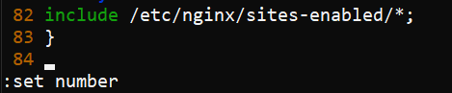

sudo vim /etc/nginx/sites-available/exemplo.com

**New lite conf Amazon-Linux**

server {

listen 80 default_server;

listen [::]:80 default_server;

root /var/www/test.com/html;

index index.html index.htm;

server_name test.com www.test.com;

location / {

try_files $uri $uri/ =404;

}

}

**Full conf change root location Amazon-Linux**

**##**

**# You should look at the following URL's in order to grasp a solid understanding**

**# of Nginx configuration files in order to fully unleash the power of Nginx.**

**# http://wiki.nginx.org/Pitfalls**

**# http://wiki.nginx.org/QuickStart**

**# http://wiki.nginx.org/Configuration**

**#**

**# Generally, you will want to move this file somewhere, and start with a clean**

**# file but keep this around for reference. Or just disable in sites-enabled.**

**#**

**# Please see /usr/share/doc/nginx-doc/examples/ for more detailed examples.**

**##**

**# Default server configuration**

**#**

**server {**

**listen 80 default_server;**

**listen [::]:80 default_server;**

**# SSL configuration**

**#**

**# listen 443 ssl default_server;**

**# listen [::]:443 ssl default_server;**

**#**

**# Note: You should disable gzip for SSL traffic.**

**# See: https://bugs.debian.org/773332**

**#**

**# Read up on ssl_ciphers to ensure a secure configuration.**

**# See: https://bugs.debian.org/765782**

**#**

**# Self signed certs generated by the ssl-cert package**

**# Don't use them in a production server!**

**#**

**# include snippets/snakeoil.conf;**

**root /home/site/www;**

**# Add index.php to the list if you are using PHP**

**index index.html index.htm index.nginx-debian.html;**

**server_name _;**

**location / {**

**# First attempt to serve request as file, then**

**# as directory, then fall back to displaying a 404.**

**try_files $uri $uri/ =404;**

**}**

**# pass the PHP scripts to FastCGI server listening on 127.0.0.1:9000**

**#**

**#location ~ \.php$ {**

**# include snippets/fastcgi-php.conf;**

**#**

**# # With php7.0-cgi alone:**

**# fastcgi_pass 127.0.0.1:9000;**

**# # With php7.0-fpm:**

**# fastcgi_pass unix:/run/php/php7.0-fpm.sock;**

**#}**

**# deny access to .htaccess files, if Apache's document root**

**# concurs with nginx's one**

**#**

**#location ~ /\.ht {**

**# deny all;**

**#}**

**}**

**# Virtual Host configuration for example.com**

**#**

**# You can move that to a different file under sites-available/ and symlink that**

**# to sites-enabled/ to enable it.**

**#**

**#server {**

**# listen 80;**

**# listen [::]:80;**

**#**

**# server_name example.com;**

**#**

**# root /var/www/example.com;**

**# index index.html;**

**#**

**# location / {**

**# try_files $uri $uri/ =404;**

**# }**

**#}**

**Enable the file by creating a link from it to the sites-enabled directory, which Nginx reads from during startup:**

sudo ln -s /etc/nginx/sites-available/your_domain /etc/nginx/sites-enabled/

**PHP**

**check php v:**

php v

**check php status:**

sudo systemctl status php7.4-fpm

**After install php on Nginx go in /etc/nginx/sites-available/default #uncomment or add**

server {

...

location ~ \.php$ {

include snippets/fastcgi-php.conf;

fastcgi_pass unix:/var/run/php/php8.0-fpm.sock;

}

...

}

**get index.php by default add**

location / {

index index.php index.html index.htm;

try_files $uri $uri/ =404; }

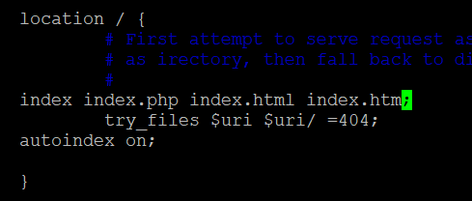

**Instalando o PhpMyAdmin**

sudo apt-get install phpmyadmin

cd /usr/share/nginx/www

sudo ln -s /usr/share/phpmyadmin

<http://192.168.5.4/phpmyadmin/index.php>

**Para acessar por** <http://192.168.5.4/phpmyadmin/>

sudo vim /etc/nginx/sites-available/default

Adicionar index.php na linha 25

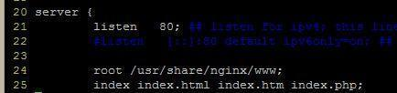

**Instalação Wordpress**

$ sudo cp –r wordpress/* /meusite

**Configure:** wp-config.php

$ sudo chown www-data:www-data /var/www/meusite/*

**WordPress permalinks**

Abrir o arquivo de configuração do site

/etc/nginx/sites-available/  
or  
/etc/nginx/sites-enabled/

E depois da linha 30 adicionar

try_files $uri $uri/ /index.php?q=$uri&$args;

e comentar a linha anterior

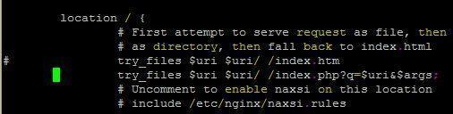

**Redirecionar URL:**

<http://www.drivebr.com/wp-content/uploads/imagem.jpg>  
para  
<http://www.1drivebr.com/wp-content/uploads/imagem.jpg>

server {

listen 80;

server_name www.drivebr.com;

return 301 $scheme://www.1drivebr.com$request_uri;

}

**Redirecionar o IP do servidor para qualquer site**

/etc/nginx/sites-enabled/default

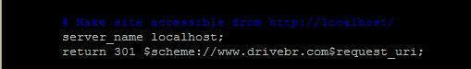

References:

<http://nginxlibrary.com/wordpress-permalinks/>

Virtual: <http://www.farinspace.com/nginx-virtual-host/>  
Server Blocks<http://wiki.nginx.org/ServerBlockExample>  
<https://www.digitalocean.com/community/articles/how-to-set-up-nginx-virtual-hosts-server-blocks-on-ubuntu-12-04-lts--3>

<http://stackoverflow.com/questions/10294481/how-to-redirect-a-url-in-nginx>

<https://www.digitalocean.com/community/articles/how-to-install-phpmyadmin-on-a-lemp-server/>

**How To Install Linux, Nginx, MySQL, PHP (LEMP) stack on Ubuntu 12.04**

Instalação completa - mysql, php, configurando nginx para trabalhar com php

<https://www.digitalocean.com/community/articles/how-to-install-linux-nginx-mysql-php-lemp-stack-on-ubuntu-12-04>

<https://gist.github.com/sanrandry/bd4350a591f62eb259e48cd9fbfcd642>